Instructional Guide for Flashing Firmware via USB Cradle

***IMPORTANT NOTE:*** Flashing a Firmware via USB cradle only works in a Windows platform because the hardware driver is available for Windows only.

Here are the things you need before flashing the latest Firmware on your Kreyos Meteor via USB cradle:

1. Kreyos Meteor

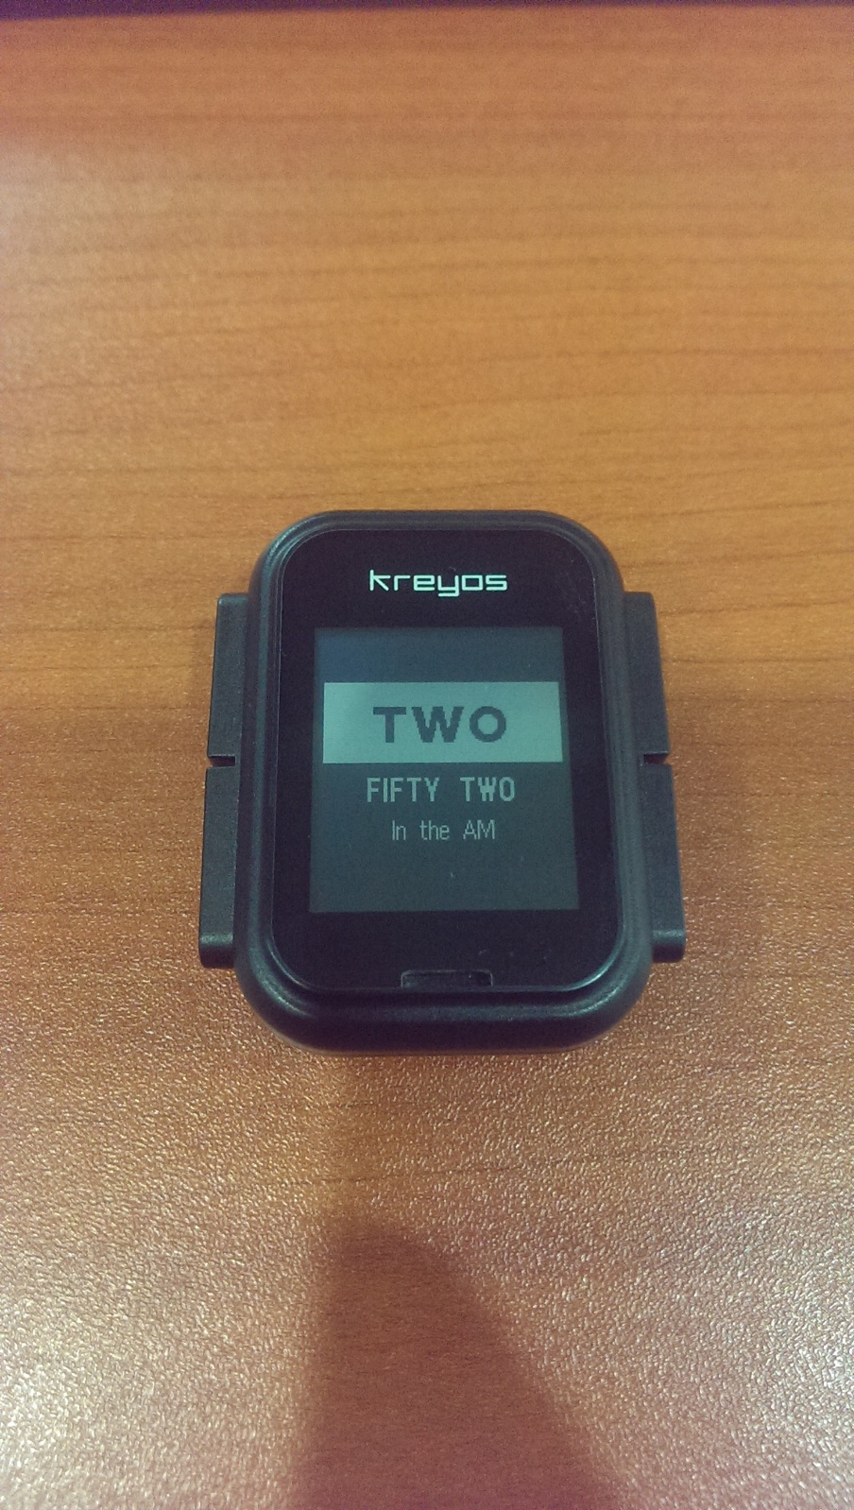

1. Kreyos Meteor charger (USB cradle)

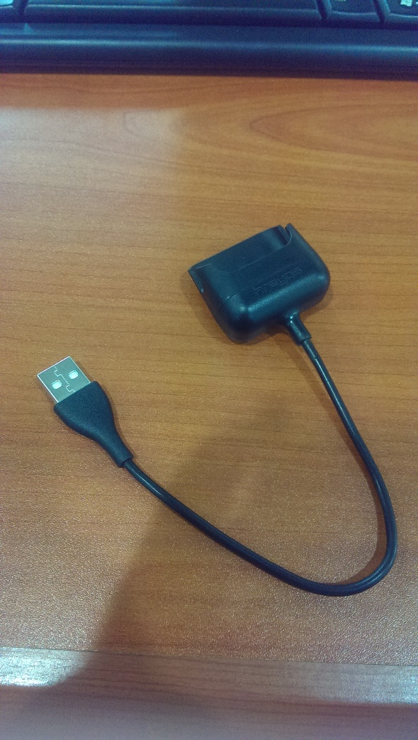

1. ‘KreyosFirmware’ folder

* This folder contains the following files:
  + BSL executable file (BSL.exe)
  + run batch file (run.bat)
  + firmware binary file version 1.0.0.1071 (firmware.bin)
  + Commands: (prog, reset)

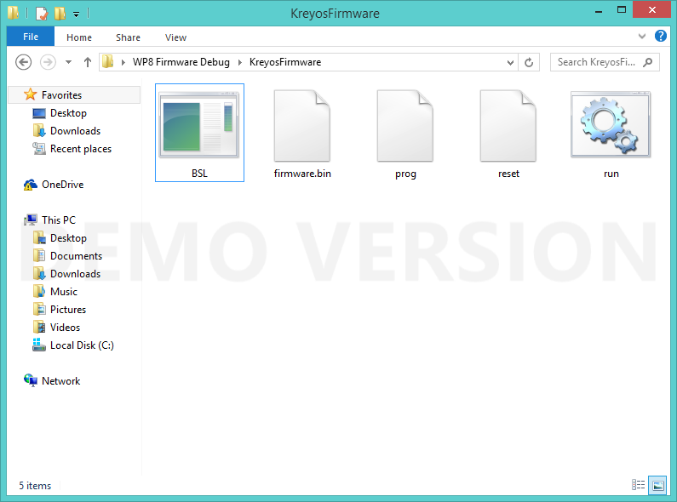

1. ‘CP210x_VCP_Windows’ folder (Hardware driver)

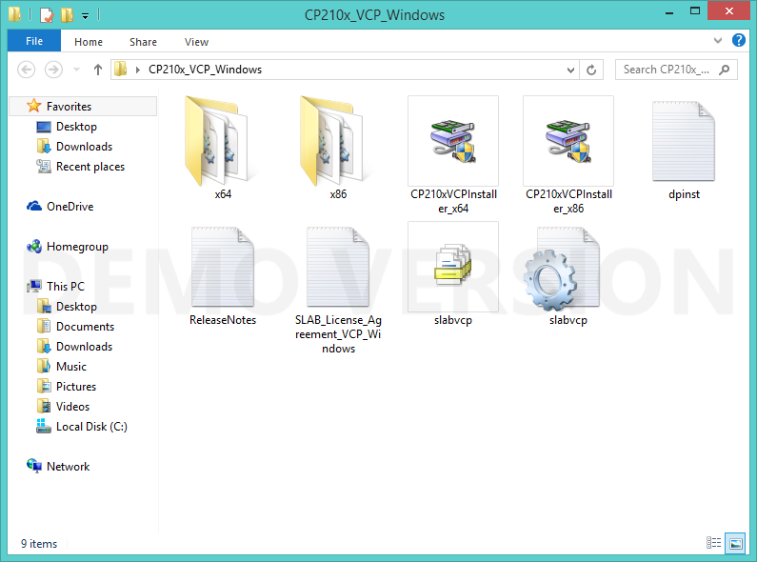

There are 2 commands that you can input in Command Prompt:

* bsl reset
  + Initial log checking on the watch
* bsl prog/run
  + flush the new firmware to watch

Here are the steps for flashing the firmware to the watch via the USB cradle:

1. Install the driver
   * To do this, go to the ‘CP210x_VCP_Windows’ folder



* + Click on either ‘CP210xVCPInstaller_x64’ or ‘CP210xVCPInstaller_x86’ depending on your OS system type. to install the hardware driver



* + ***IMPORTANT NOTE:*** ‘CP210xVCPInstaller_x64’ is for 64-bit OS while ‘CP210xVCPInstaller_x86’ is for 32-bit OS.

1. Plug the watch to your computer
   * Make sure the “Battery is charging.” screen is showing on the watch

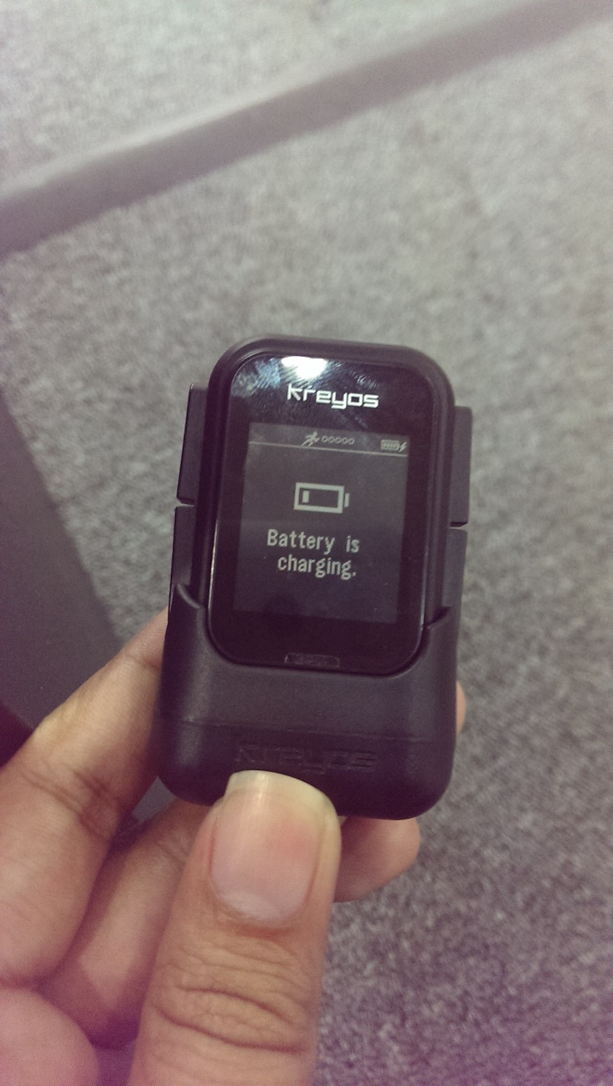

1. Locate the 'KreyosFirmware' folder
   * To do this, open the Command Prompt
   * Locate the 'KreyosFirmware' folder directory
   * ***IMPORTANT NOTE:*** Copy the ‘KreyosFirmware’ folder to drive C: for easier access.

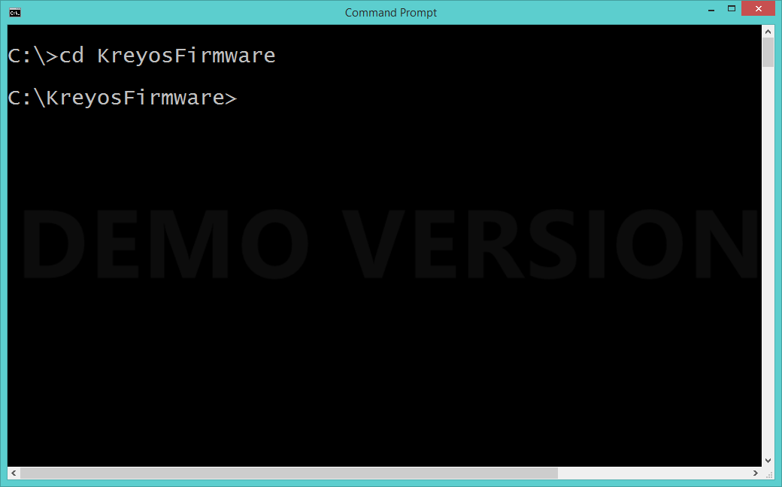

1. Run the command 'bsl reset' to check if watch is connected
   * After locating the ‘KreyosFirmware’ folder on the Command Prompt, enter “bsl reset” to initialize checking on the watch. The Command Prompt should display the following:
   * ***IMPORTANT NOTE:*** Press Ctrl+C to be able to run a new command

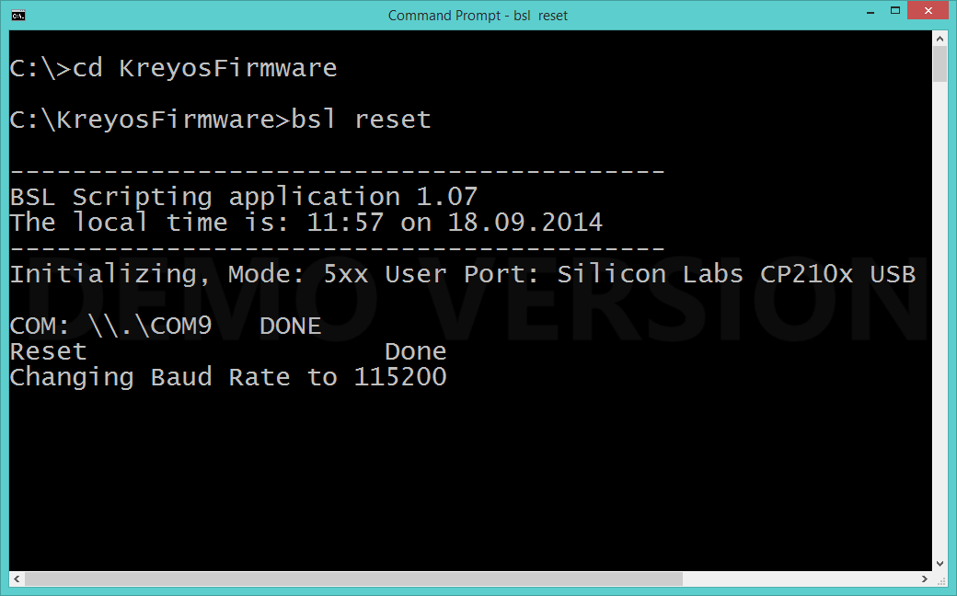

1. Run the command ‘run' or ‘bsl prog’ to flush the firmware.

